**IFT 266 Introduction to Network Information Communication Technology   
  
Lab 15**

**Cisco Discovery Protocol (CDP)**

**After you complete each step, put an ‘x’ in the completed box**

**or**

**Answer the open question**

Most of the Cisco devices can talk to each other.

These Cisco devices can see each other as soon as you power on the link and connect them with Ethernet cable.

1. Create the following network topology on Packet Tracer

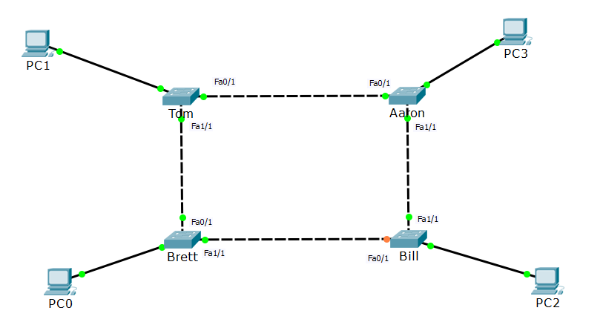

All the switches are on, plugged in and links are up (green).

We do however have one orange link (spanning tree has blocked that link so we do not have a loop).



1. Click on Brett and go to the CLI tab (command prompt), go into enable mode and type the “show cdp” command

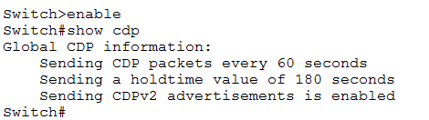

The first piece of information tells us the switch will send CDP packets every 60 seconds and have a hold time of 180 (we come back to the holdtime later in the lab).

The switch will send out a CDP signal out each link every 60 seconds.

This CDP signal is like ‘hello packets’ which say “hi, I’m a switch, I’m here and would like to know you”.



1. Now type in show cd ? command.

This command will provide us with extra parameters/stuff that we can see.

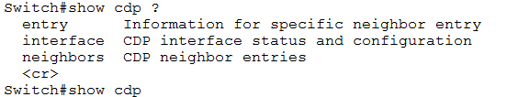



1. From previous step, we will look at show cdp neighbors command which allows us to see what else is out there…

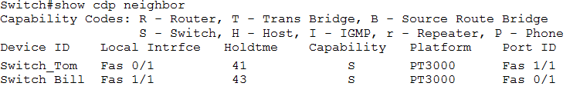

So “Brett” sees Tom and Bill. The local interface says that I’m reaching Tom via 0/1 interface.

Brett to Bill goes out via interface 1/1.

Platform 3000 is the model of the other switch which we are connected to.

On the Port ID, this is other side’s ports which are connected to us. Tom is connecting to Brett via Fa1/1

Show cdp neighbors is very useful when you go onto an unknown network of Cisco routers and switches so you can see what is connected to what.



1. Another command we can use is the CDP neighbors detail.

This command gives us far more detail i.e. IP addresses if any are configured and IOS versions (what software that device is running)

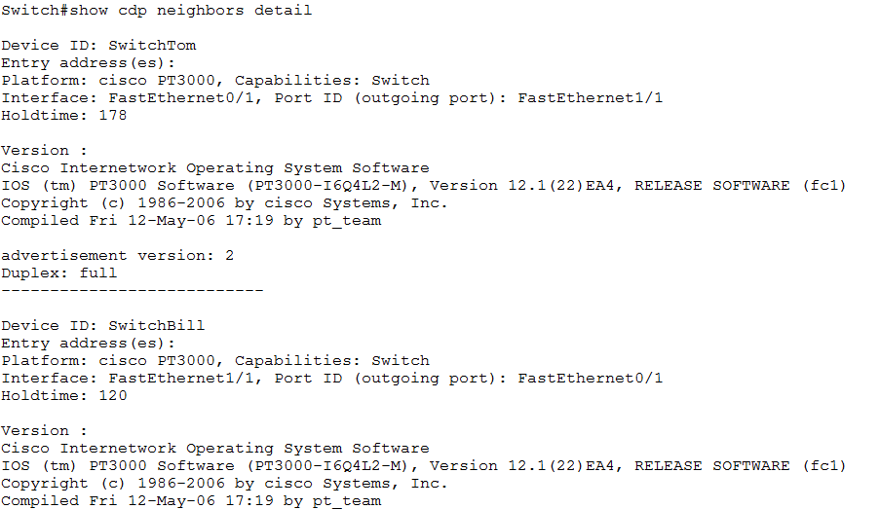



1. Now we will configure an IP address on Tom (you should be quite familiar with this process by now).   
     
   As you can see the VLAN is not turned on.

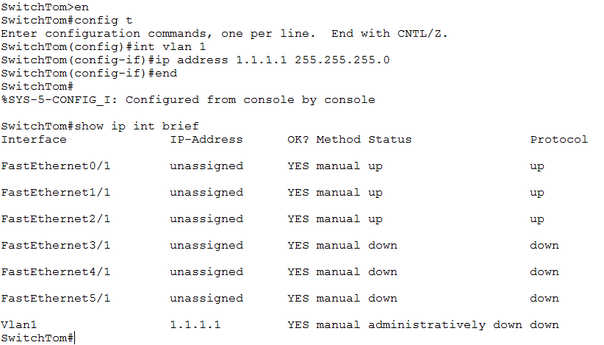



1. Now turn on the VLAN

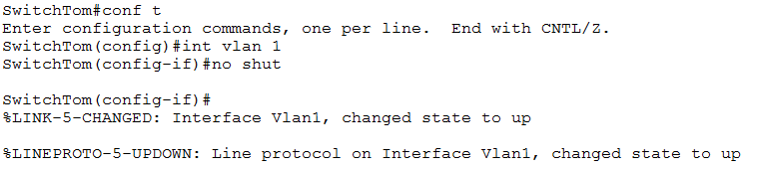



1. Now re-run the show i pint brief command and see the updated status of the VLAN which is no up and up

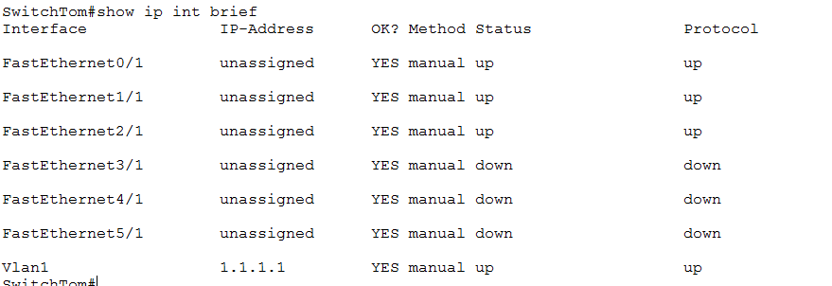



1. Now go back to Brett and run the command show cdp neighbors detail.  
     
   We can now see the IP address that we setup on Tom. It shows that there is an IP address on that particular switch.

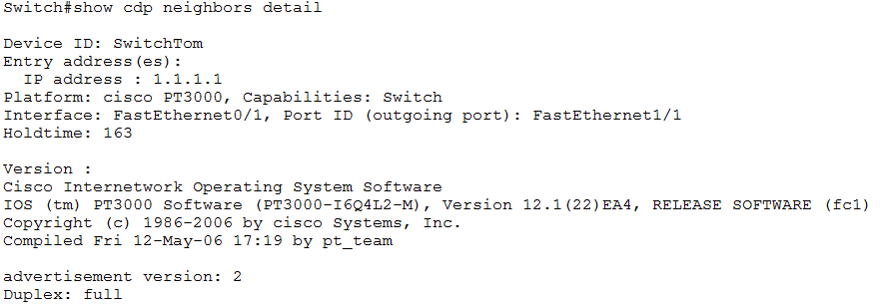



1. So far we not configured nothing on Brett i.e. no IP addresses, nothing at ll.

If I have no IP addresses setup on Brett, how do I see the IP address on Tom?

CDP exchanges information on a lower level i.e. exchanges information on layer 2.

So as long as you have a link and the lights are on (green) you can exchange information including IP addresses to the IOS version.

If you are in a high security environment, you may want to turn off CDP off.

Go into Tom and type the ‘no cdp run’ command which will kill CDP for the entire switch

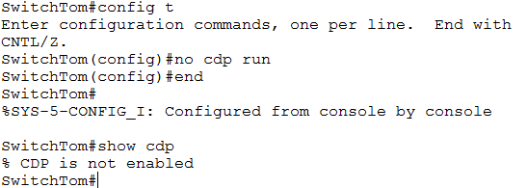

CDP is not enabled on Tom anymore.



Go into Brett and type show cdp command and now let’s looks at the holdtime value.

This holdtime value means that if you do not receive any information from your neighbors in 180 seconds, you will consider the other side to be dead and take it out of your table.

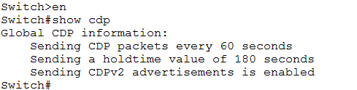



Now run show cdp neighbors and Tom has disappeared from the table as the holdtime eventually hits zero and drops from the table.

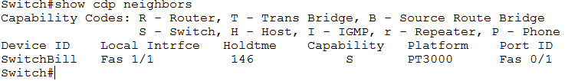

1. You can just turn off CDP on particular interfaces rather than the whole switch by going into that interface like when you are connecting to another provider’s device as they will not need to see your devices details.

  
  
